**NAME---HARSH KUMAR**

**ID---B219027**

**BRANCH---CE-4TH SEM.**

**DATE--- 26-02-2021**

LAB-6

1. List all distinct values for a column.

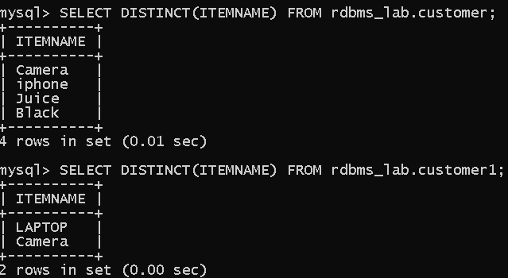

2. List employee names whose salary is between 2000 and 3000.

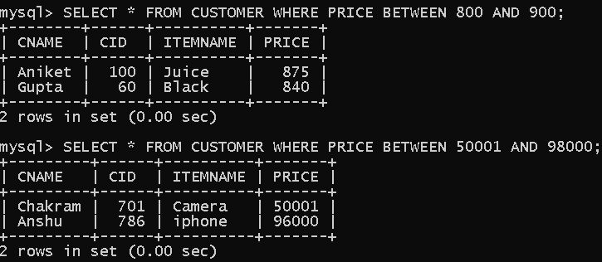

3. List employee in the dependent 10,20. (specifically selects from the given list, list can be more)

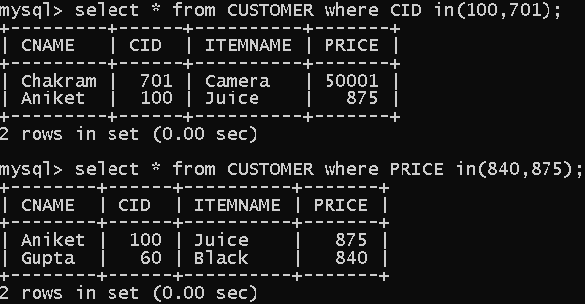

4. List employee names which begin with S.

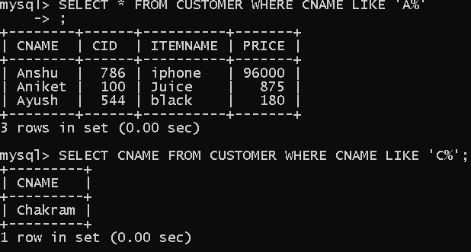

5. List employee names having ‘A’ in their names.

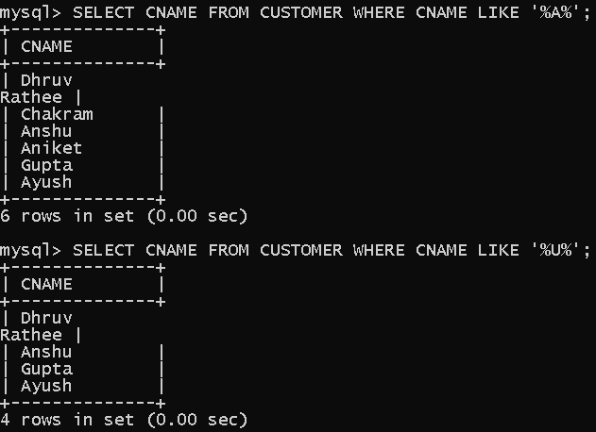

6. List the numbers of people and average slary in deptno 30.

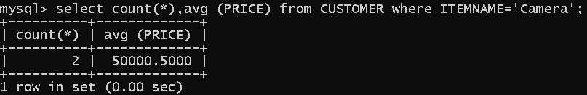

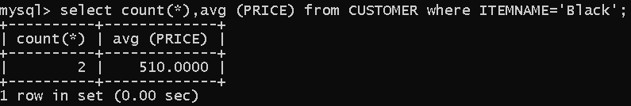

7. Nested queries. Write a nested query to retrieve the First name.

